REST API ( 80%)
- REST is an architectural style rather than a protocol.
- It utilizes standard HTTP methods (GET, POST, PUT, DELETE) to perform operations on resources identified by URL.
- REST - Representational State Transfer.
- JSON and XML
- Client -> Server - JSON Or XML - JSON 85%
- Light Weight way to communicate via the HTTP methods
- JSON (text based message) - Key and Value pairs.
- Major Companies - REST APIs.
- JSON - human friendly.

Project#2 - Rest API -
Restful-booker is a Create Read Update Delete Web API that comes with authentication features and loaded with a bunch of bugs for you to explore.

SOAP v/s REST:-
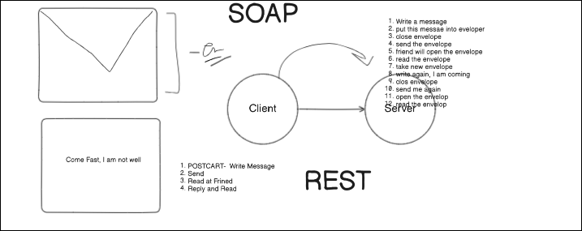

- API Documentation
  - Requirement - ﻿restful-booker.herokuapp.com/apidoc/index.html
- Understand the Projects
  - Objective -> Create a Booking, Update Booking, Delete a Booking, Fetch a Booking.
  - HTTP Methods
  - Do you have any UI? -> No
- Request
  - URL
  - HTTP Method
  - Auth ? - Token , U/P
  - Cookie
  - Payload / Body
  - Header - content-type, user-agent
  - Parameter
- Response
  - Status Code
  - Body
  - headers
  - Response time
What To Test in APIs?
- Validation of Response
  - HTTP Status Code.
  - Verify the Parses JSON or XML response.
  - Verify Headers response with Negative or invalid headers.
  - Max/ Min Key values.
  - Missing Keys
  - Empty Updates or POST call handling.
- headers
- Status Code
- Authorization
- CRUD operations
- Duplicay, Erros message. Invalid and Valid
- Boundary Values
- time
- Database integrity test

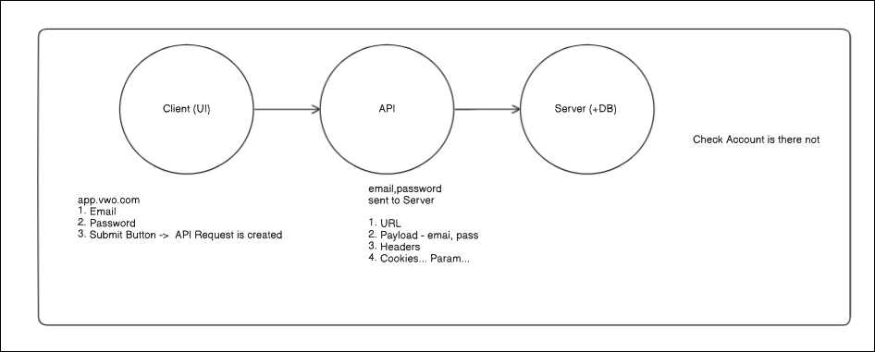

Common Bugs in API?
- Test nulls and empty strings, these have a habitat of causing issues ;).
- Test with American, Chinese, arabicUnicode characters, ensure they are correctly saved to the database.
- Test mandatory and optional parameters, in particular test with just mandatory values.
  - API Documentation.
  - firstname - mandatory
  - additonal is optioanal
- Functionality Bugs: the test looks for missing functionality bugs.
- Reliability Bugs: API testing helps identify bugs pertaining to integration across different systems.
  - Registration API ( created user, Pramod) -> Login API - ti should be able to login.

- Client -> Server
- We need something which can be understandable by both. - Client, Server
- Client - Python
- Server - Java
- API ( Transfer of the data ) - JSON
What is JSON?
- JSON stands for JavaScript Object Notation.
- JSON is a text format for storing and transporting data.
- JSON is "self-describing" and easy to understand.
- JSON is language independent *.
- JSON is used to send data between computers
JSON. - Python, Java, JS, Ruby... supported. all of them.
Follows - key and value
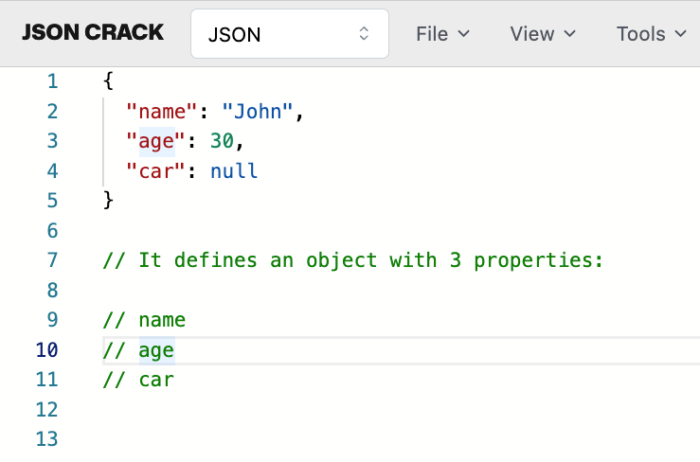
In JSON, values must be one of the following data types:
- a string
- a number
- an object (JSON object)
- an array
- a boolean
- null
JSON values cannot be one of the following data types:
- a function
- a date
- undefined
How to Test Project?
- API Documentation - Import the Request to POSTMAN
  - Create Your Own Req.
- Write the Testcases in the Excel
- Write the in Postman
- Execute in the Postman
- Report the Bugs -
- Test Report -> HTML Report

